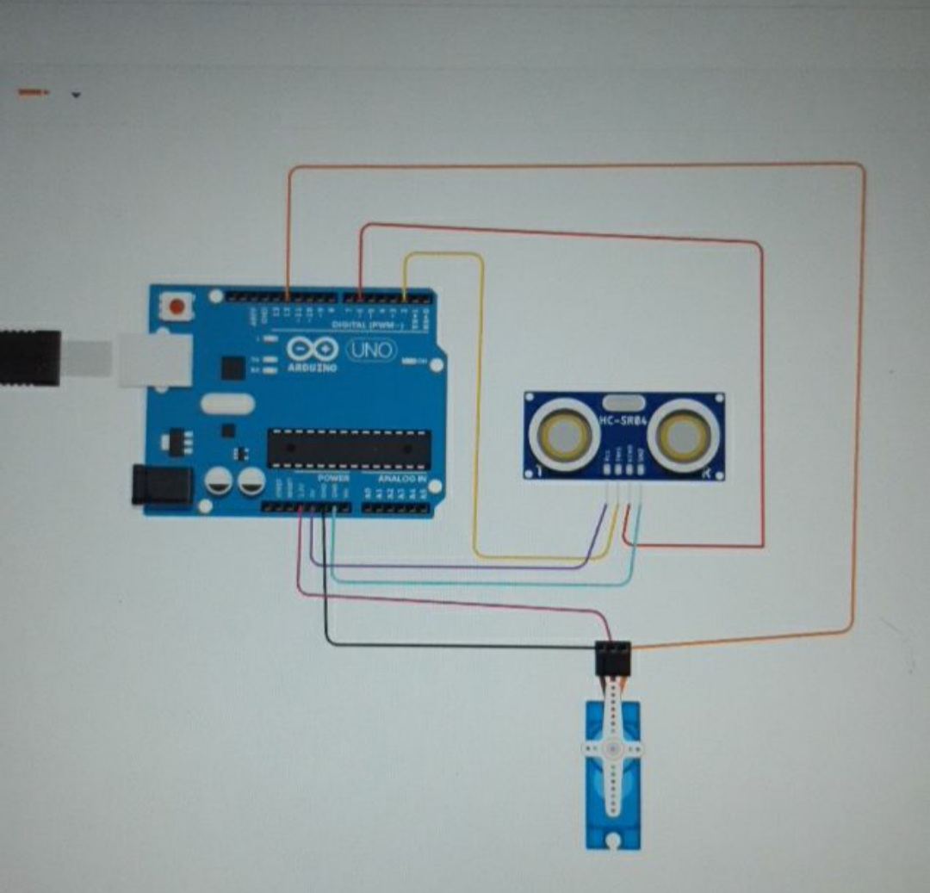

**19R11A04J2**

**R.PRERNA**

**ECE-D**

ASSIGNMENT -2 UPDATED NAME:- R.PRERNA ROLLNO:- 19R11A04J2

CIRCUIT:-

CODE:-

// C++ code

//

#include <Servo.h>

int obj_distance = 0;

Servo servo_12;

long readUltrasonicDistance(int triggerPin, int echoPin)

{

pinMode(triggerPin, OUTPUT); // Clear the trigger

digitalWrite(triggerPin, LOW);

delayMicroseconds(2);

// Sets the trigger pin to HIGH state for 10 microseconds

digitalWrite(triggerPin, HIGH);

delayMicroseconds(10);

digitalWrite(triggerPin, LOW);

pinMode(echoPin, INPUT);

// Reads the echo pin, and returns the sound wave travel time in microseconds

return pulseIn(echoPin, HIGH);

}

void setup()

{

servo_12.attach(12, 500, 2500);

Serial.begin(9600);

}

void loop()

{

servo_12.write(0);

obj_distance = 0.006783 * readUltrasonicDistance(2, 6);

if (obj_distance <= 50) {

servo_12.write(90);

Serial.println("OBJECT IS NEARBY");

} else {

servo_12.write(0);

Serial.println("OBJECT IS FAR AWAY");

}

delay(1000); // Wait for 1000 millisecond(s)

}

**OUTPUT:-**

